Practical Assessment IT5039

Responsive Web Development:

*\*To begin the practical assessment, I decided to make a home webpage for a fake dental business- Kale Dentistry. The contents of the page would remain simple, but would include the use of both flex and grid functions to display the services that they offer, their staff, and their location.*

I began with creating a single webpage, focusing on the layout within a desktop/laptop format using Visual Studio Code. This included creating lists for the navigational aspects of the page (the header links and services links), and implementing both flex and grid displays to assist with layout. As I was creating the webpage and experimented with different positions, I manually changed the size of the window/screen to ensure that the content did not get messy and remained responsive. Once I finished adding all of the content into the HTML and implementing a simple CSS design, I focused more on the responsiveness of the site on different devices- desktop/laptop, tablets, and mobile phones. I tested any changes and developments I made using the ‘Inspect’ element on the webpage, both to check how it worked with various device windows, but also with fixing any format issues within the design. The biggest issue I faced with that was remembering to input values as percentages where necessary to ensure that it would adapt to the window size, and manipulating the size of the multimedia (which I decided to use Google Maps).

The tool/technique I used to implement responsiveness was the @media screen media query code in the CSS spreadsheet. This allowed me to specify the maximum and minimum width of screens to represent the various device screen sizes between desktop (1920px by 1281px), tablet (1280px by 461px), and mobile (460px).

The desktop layout remained the same for the most part, and only added some minor adjustments to the appearance. For example, the layout of the services items is spread out in 4 columns and 2 rows, which is exclusive to the desktop layout. The tablet responsiveness required more alterations, such as making the background images under the section titles, spacing between links, and the google maps multimedia smaller. The services items change its grid layout to 2 columns and 4 rows (also happens when the desktop window is smaller), and the team members names and descriptions are shifted to sit beneath their staff photos as opposed to beside them. A lot the same elements were changed to become responsive for various mobile device brands (with alternative screen sizes), with the main visual difference to maintain responsiveness was having each item in the services and team members to be listed one at a time, under a single column, and increasing the size of each image to use up more focal space on the screen.

To test these changes out, I mainly did so use the Inspect tool- for the tablet, I made a custom tablet design and also tried it out using the iPad selection; alternatively with mobiles, I tested the responsiveness across 8 different mobile device options that Inspect offered, mainly ranging from Apple to Samsung devices.

Image optimisation was the next part of the webpage that I focused on. Given the number of images used on the webpage, any image I found off Unsplash.com were converted from .jpeg to .webp to increase the loading speed due to its smaller file sizes (using convertio.co). Additionally, I also used the <source> element to optimise a photo (the ‘General Dental’ photo, first on the list of services) particularly for the mobile web, so that it would display a zoomed in photo of the same image when viewed on a mobile device, and thus particularly optimised for a mobile web image. However, I only applied element once as it wasn’t visually necessary for the webpage, and has only been included to show an example of how one would optimise an image for the mobile web.

Screenshots to prove that the site is responsive to both Chrome and Firefox

**CHROME:** Fullscreen

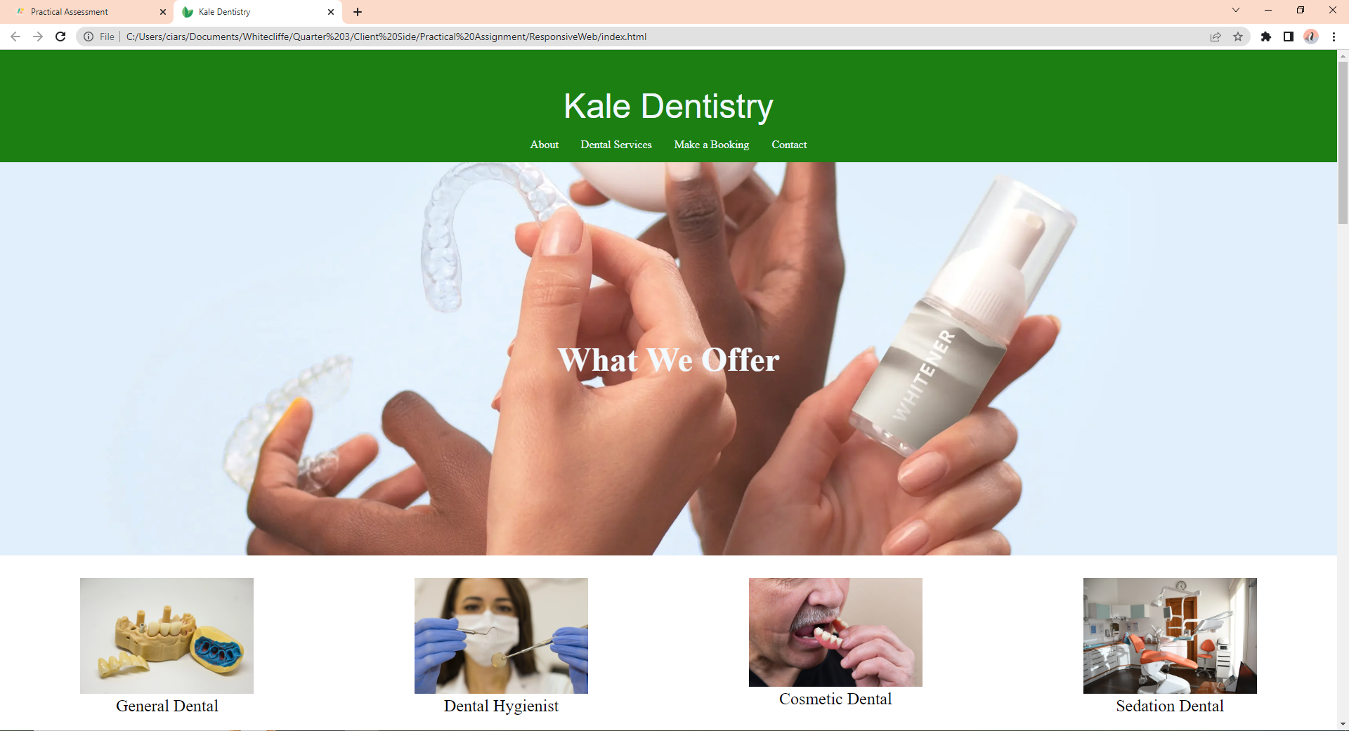

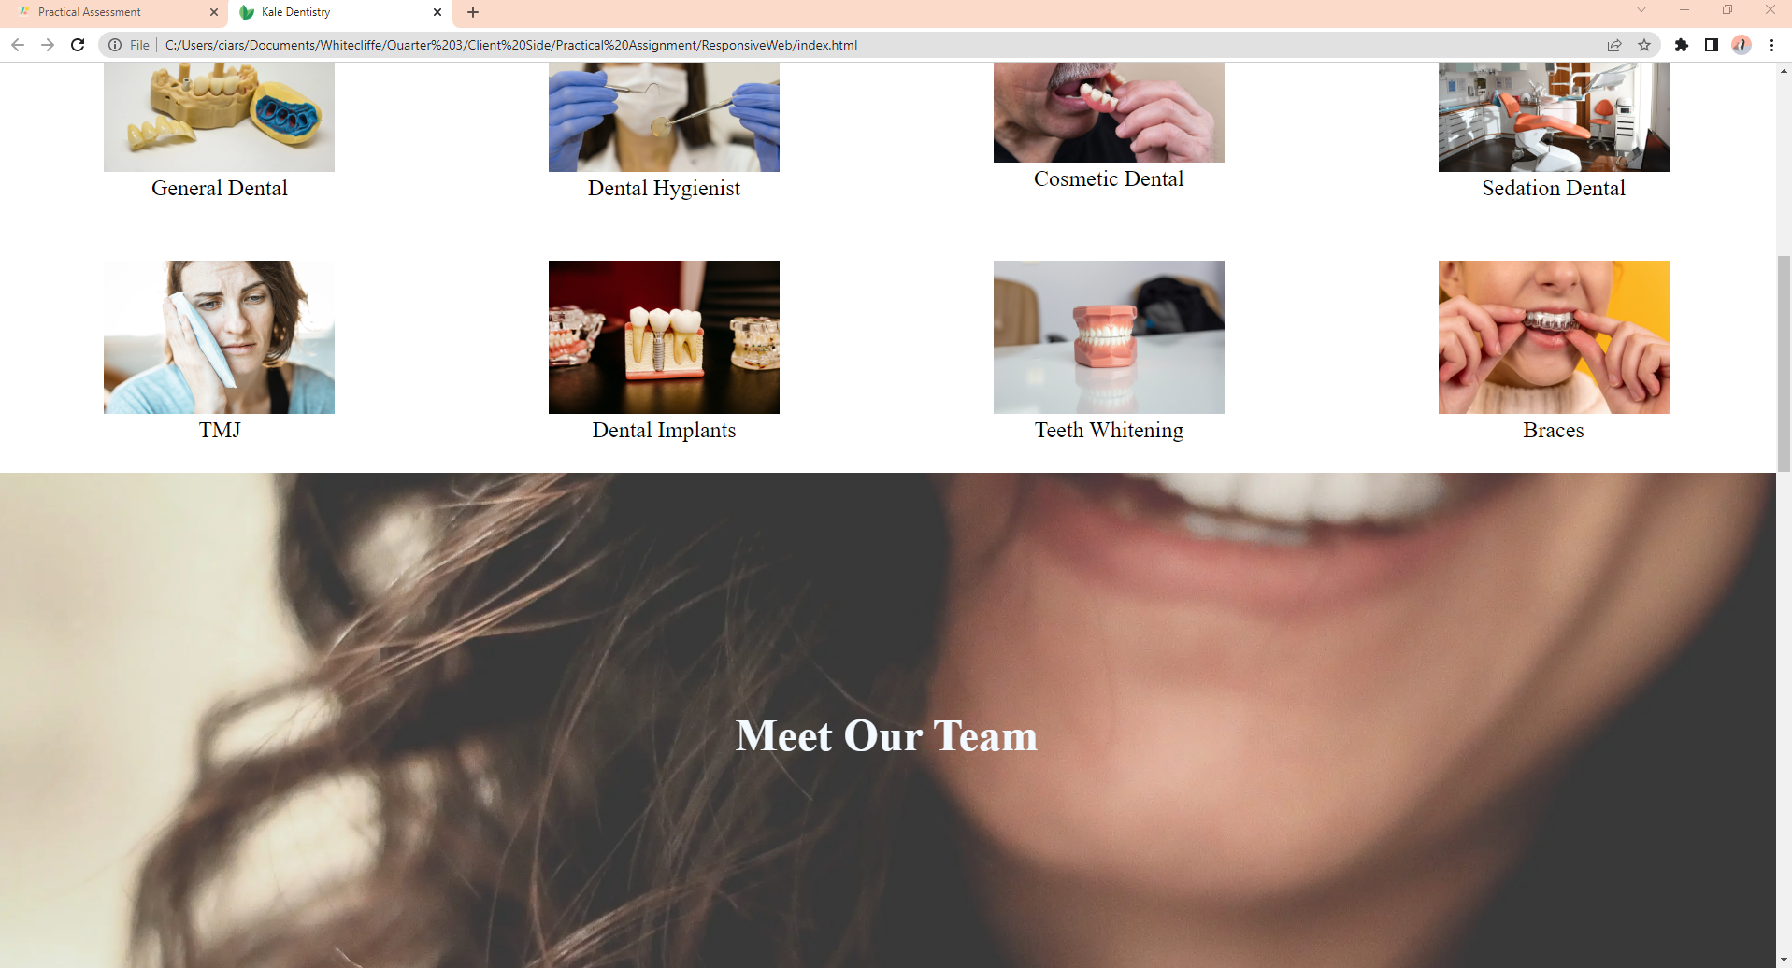

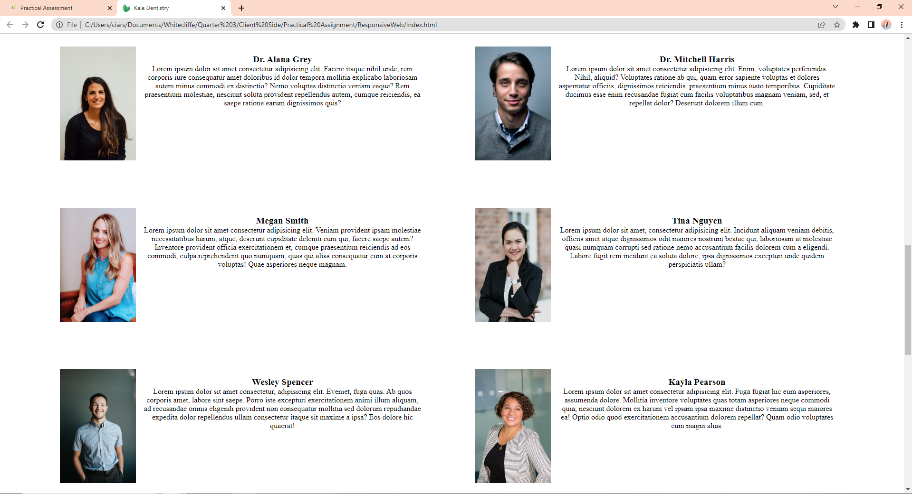

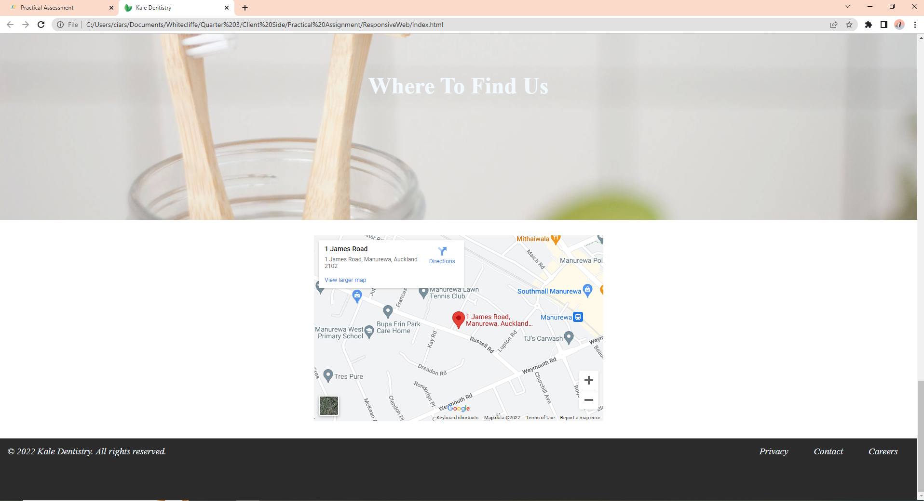

**CHROME:** window re-sizing version 1: mid re-sizing and tablet supported

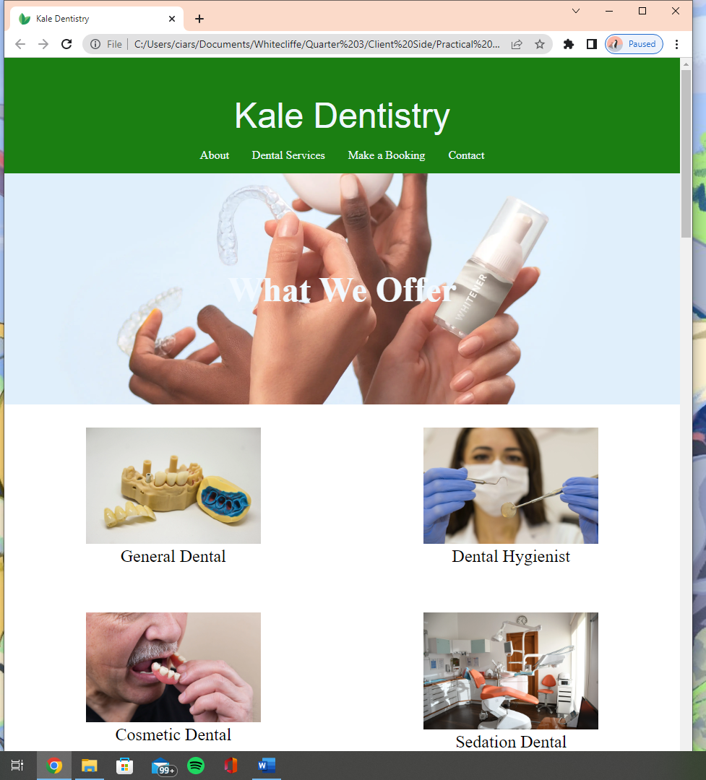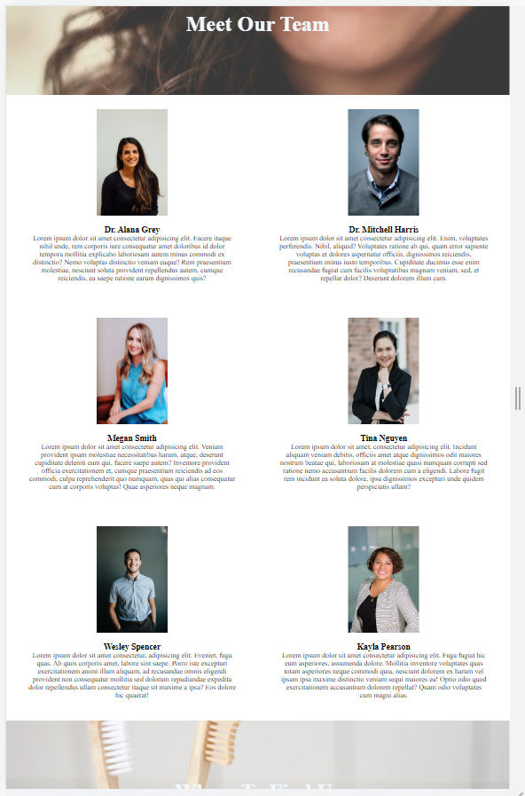

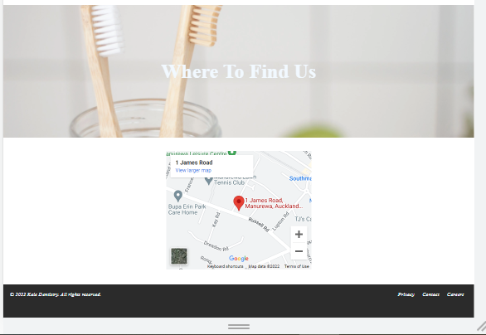

**CHROME:** window re-sizing version 1: major re-sizing and mobile phone supported

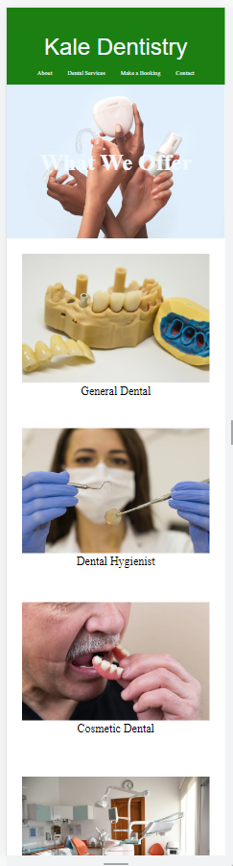 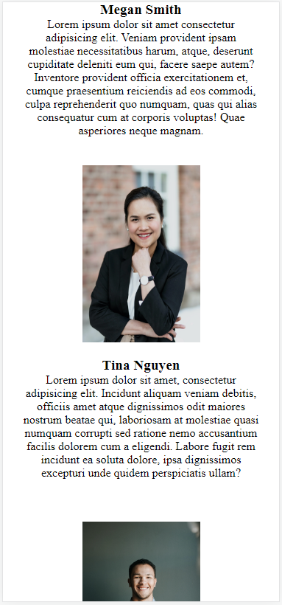 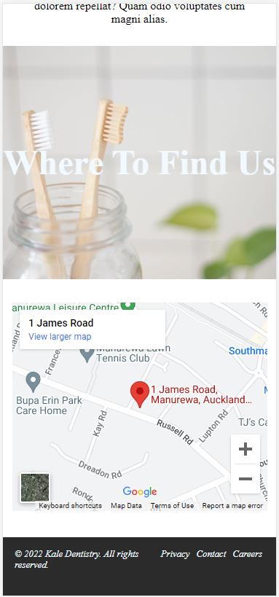

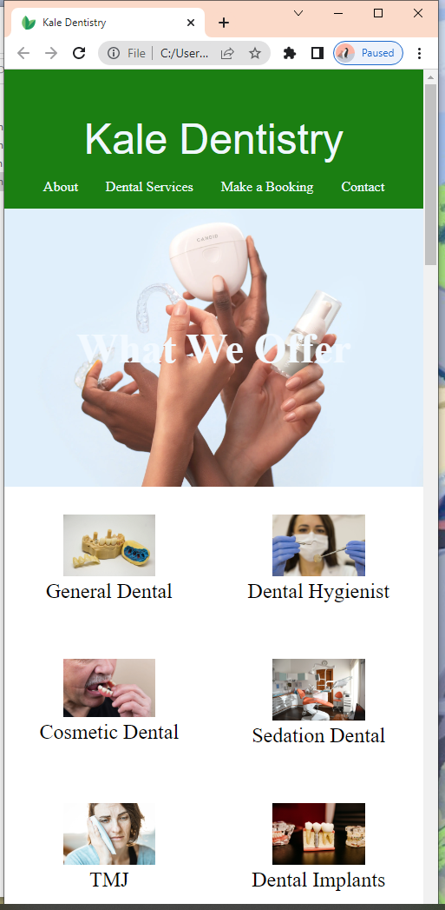

**FIREFOX:** Fullscreen

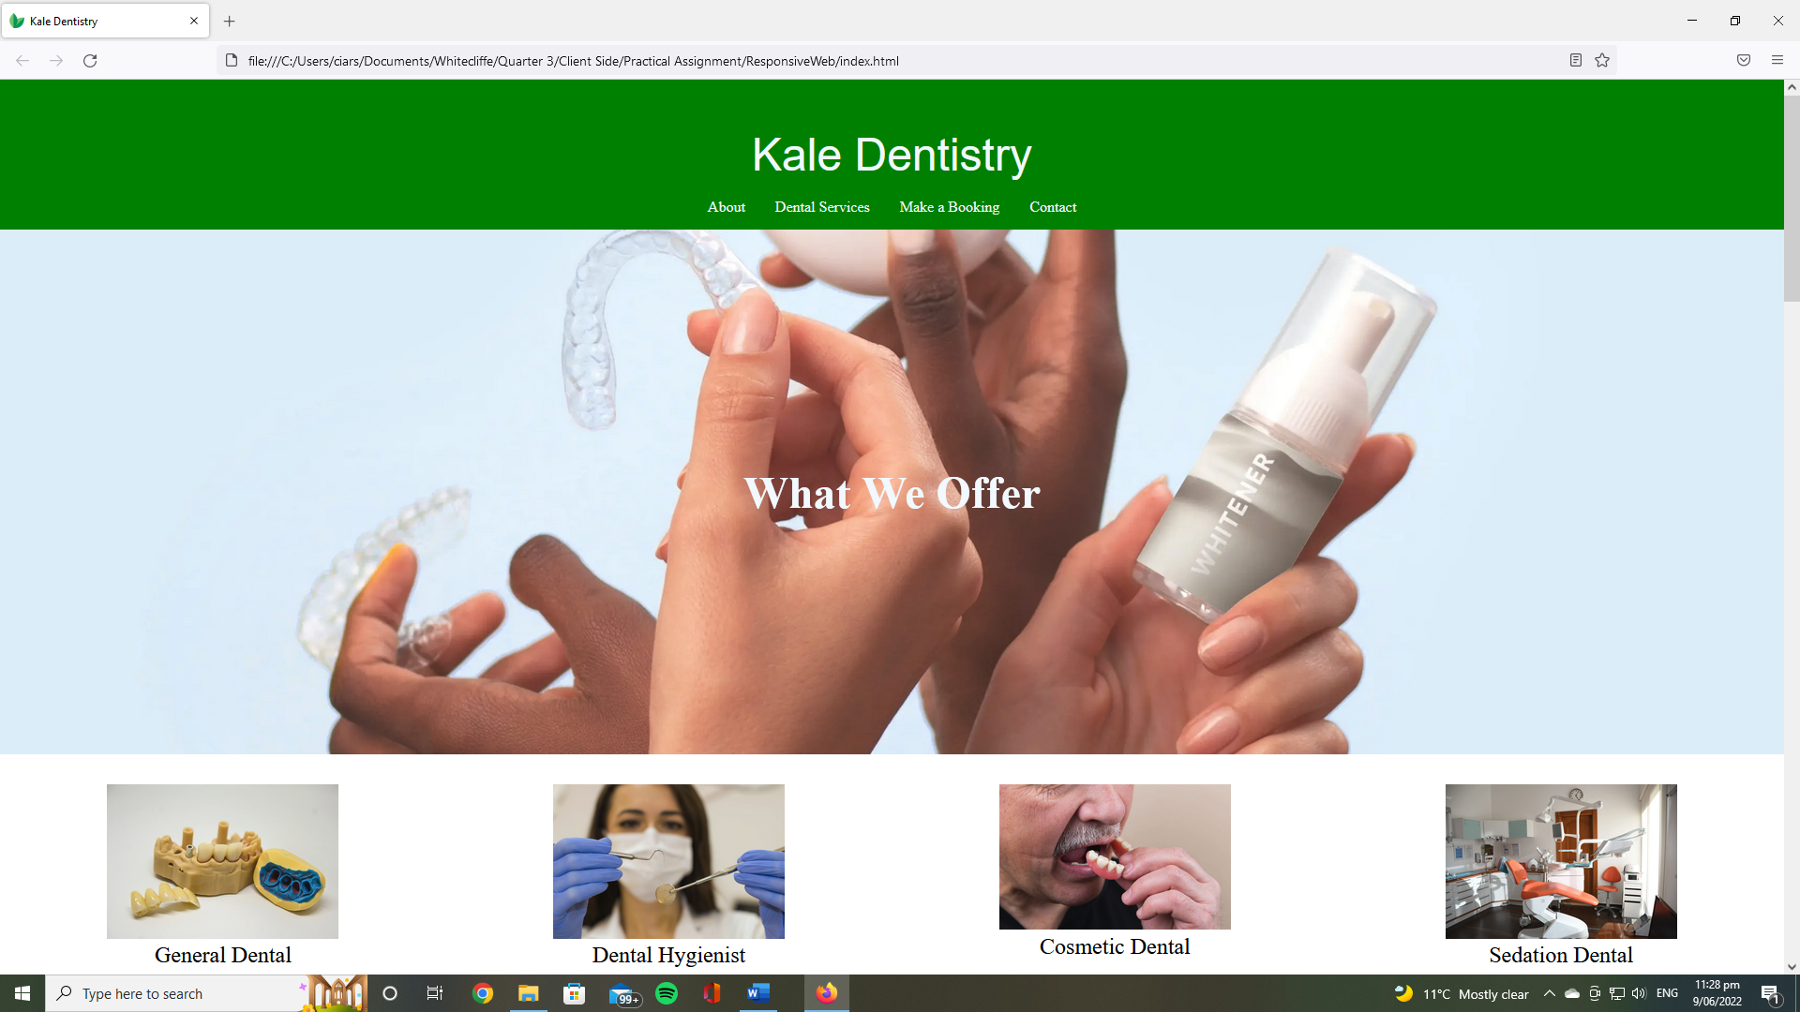

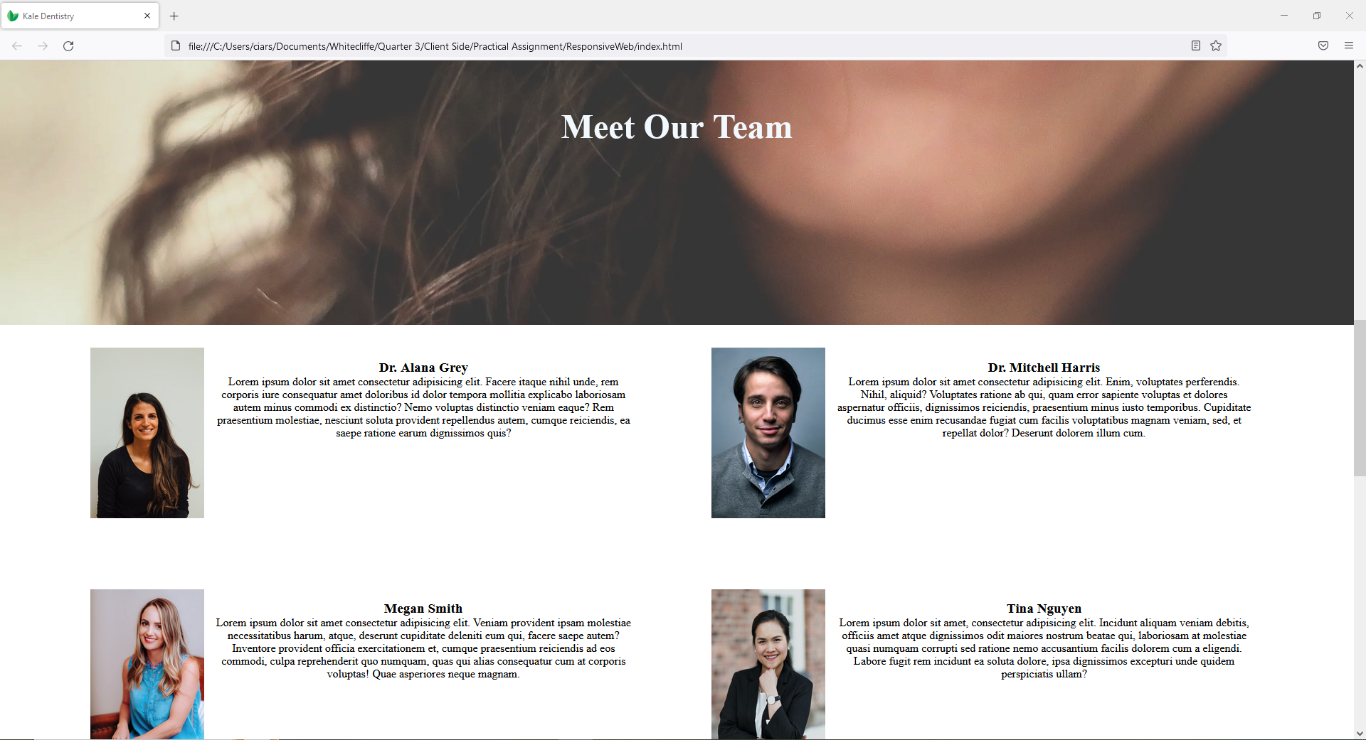

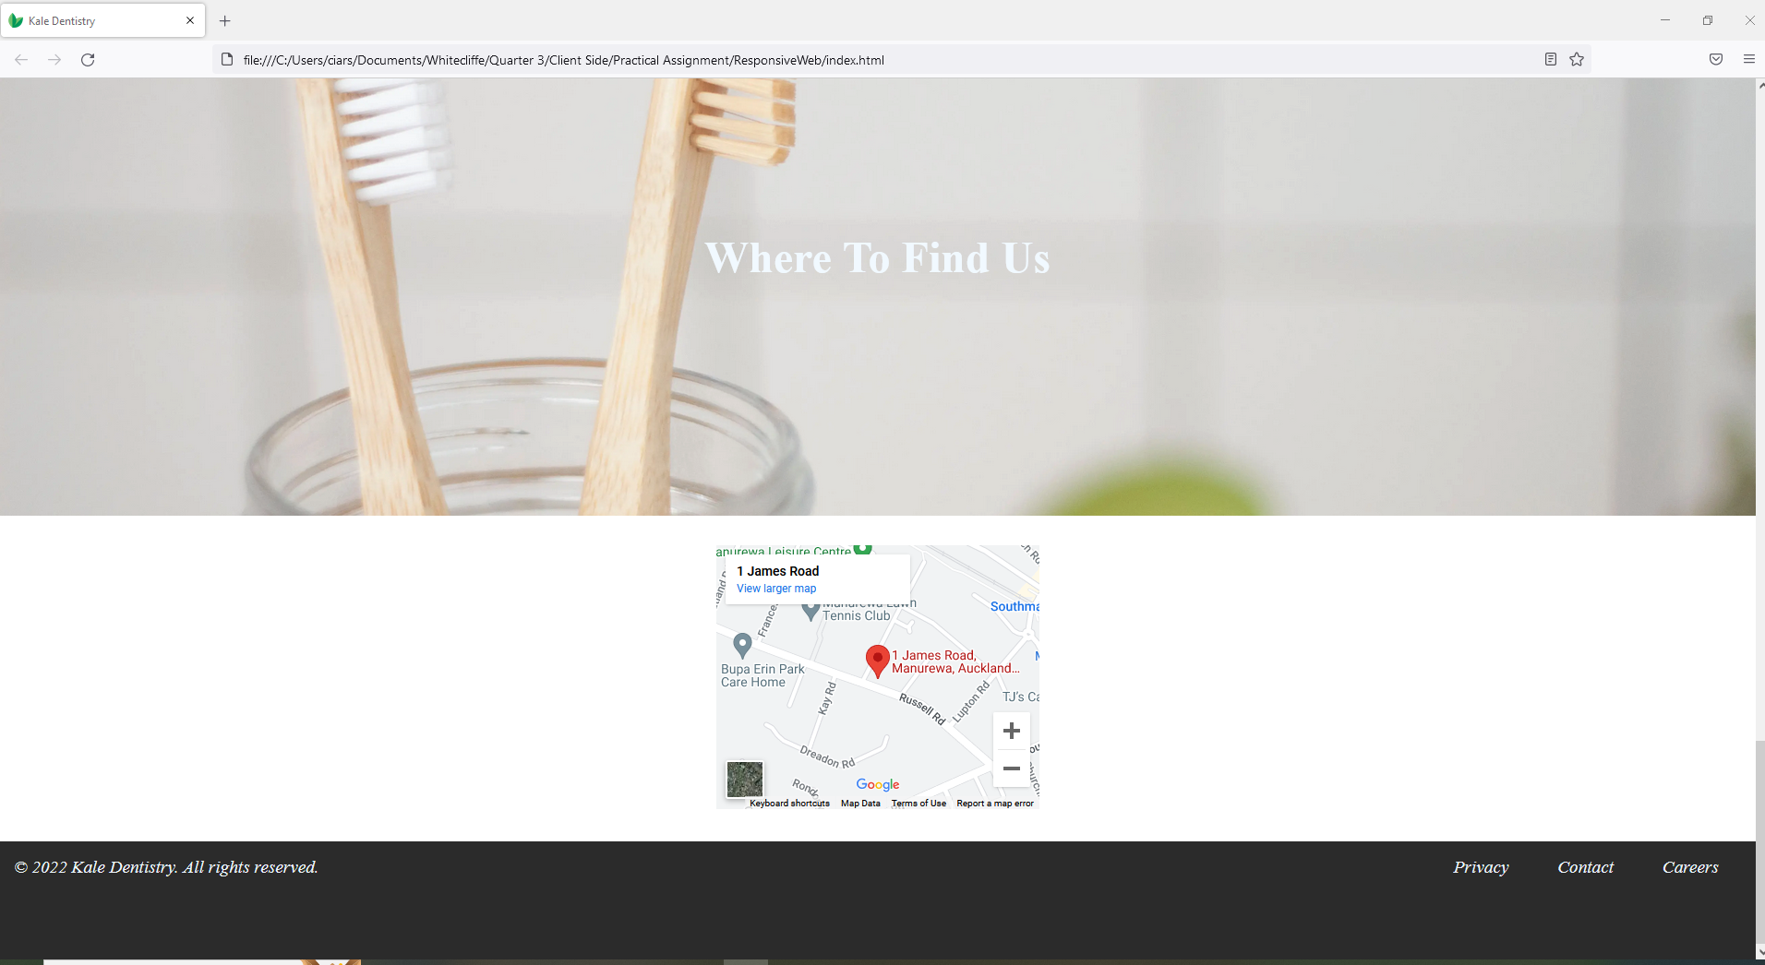

**FIREFOX:** resizing window: major (phone supported)

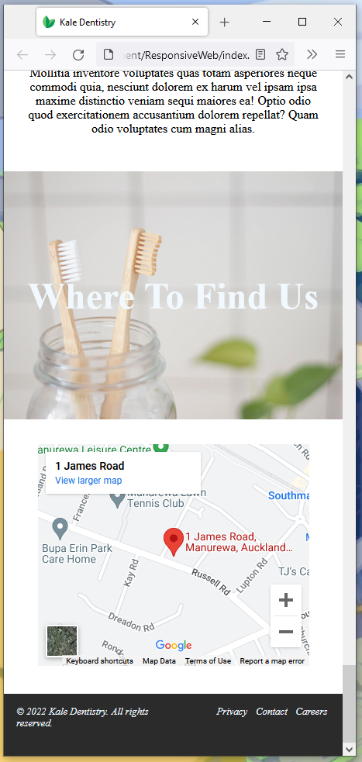

**FIREFOX:** resizing window: mid (tablet supported)

